Discussion preparation

Nozomu Ohara

Differential Advantages of Xbox One Kinect

〇Core Product

We can use Xbox One not only as game device but also as PC by using Microsoft OS.

* + - * Its OS is same as Windows 10.
      * Cortana (voice command AI assistant system) for windows 10
      * Some useful applications like Internet Explorer, One Drive, Netflix, Youtube

⇔　PS4: applications: Youtube, Netflix, hulu etc.

Wii U: applications: Youtube, hulu, original internet browser etc.

　　　　　　　　　　　　　　　　　　(playstation.com, 2018 , Nintendo.co.jp,2018)

　〇Actual Product

　・Feature

Only Xbox One realized completely controllerless gaming.

Kinect enabled us to use body as controller by its motion capture technology and voice command technology.

|  |  |  |  |
| --- | --- | --- | --- |
|  | Xbox One | PlayStation 4 | Wii U |
| Controller | Wireless controller | Wireless controller | Wii U GamePad |
| Motion Capture | Kinect for Xbox One | PlayStation Move Motion Controller | Wii Remote Controller |

(Xbox.com, 2018 , playstation.com, 2018 , nintenndo.co.jp, 2018)

　　　・Quality

Xbox one’s processing capability can be enhanced by using Microsoft’s original cloud system. This enables us to play Xbox much more smoothly.

⇔processing capability of PlayStation 4 and Wii U is limited to their processors equipped to the body.

(msn.com, 2018)

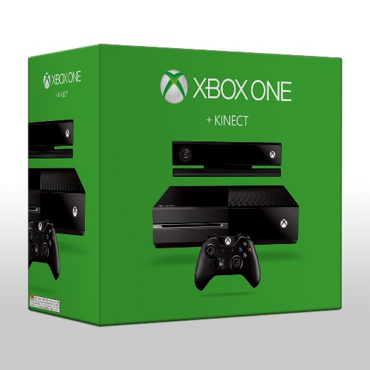

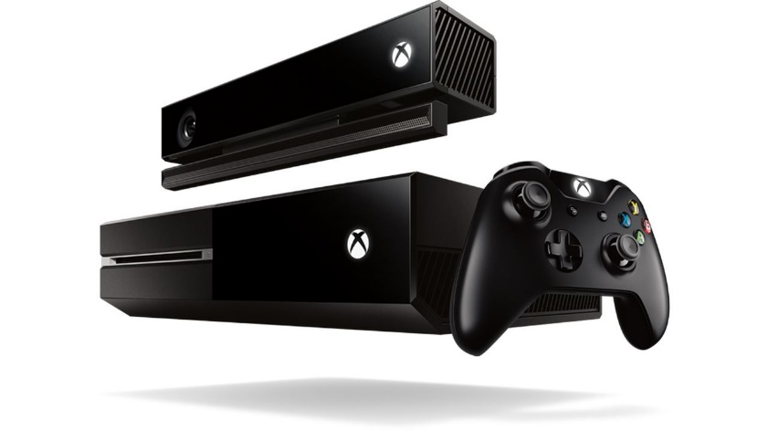

〇Reference

・xbox.com (2018). *Kinect for Xbox One*. [online] Available at: <https://www.xbox.com/ja-JP/xbox-one/accessories/kinect> [Accessed 17 May 2018]

・xbox.com (2018). *Xbox One App*. [online] Available at: <https://www.xbox.com/en-US/entertainment/xbox-one/live-apps> [Accessed 17 May 2018]

・nintendo.co.jp (2018). *Wii Uの特長*. [online] Available at: <https://www.nintendo.co.jp/hardware/wiiu/index.html> [Accessed 17 May 2018]

・playstation.com (2018). *Entertainment*. [online] Available at: <http://www.jp.playstation.com/ps4/entertainment/> [Accessed 17 May 2018]

・playstation.com (2018). *Accessory*. [online] Available at: <http://www.jp.playstation.com/ps4/accessories/> [Accessed 17 May 2018]

・msn.com (2014). *東京ゲームショウで、待望の次世代エンタメマシン「Xbox One」日本初お目見え！*[online] Available at: <https://www.msn.com/ja-jp/news/other/%E6%9D%B1%E4%BA%AC%E3%82%B2%E3%83%BC%E3%83%A0%E3%82%B7%E3%83%A7%E3%82%A6%E3%81%A7%E3%80%81%E5%BE%85%E6%9C%9B%E3%81%AE%E6%AC%A1%E4%B8%96%E4%BB%A3%E3%82%A8%E3%83%B3%E3%82%BF%E3%83%A1%E3%83%9E%E3%82%B7%E3%83%B3%E3%80%8Cxbox-one%E3%80%8D%E6%97%A5%E6%9C%AC%E5%88%9D%E3%81%8A%E7%9B%AE%E8%A6%8B%E3%81%88%EF%BC%81/ar-BB4GMVX#page=2>